Returning Ancestors within Santa Barbara County
Repository for Archaeological and Ethnographic Collections (RAEC)
University of California, Santa Barbara
Winter 2023

This report provides a brief overview of collections from Santa Barbara and Ventura Counties in the RAEC for which the campus seeks to initiate consultation.
Figure 1: Locations of sites included in this group of collections

The following are broad-stroke overviews of each collection. Details and further documentation will become available through the consultation process for those Tribes interested in making claims.
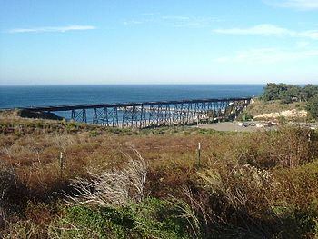
CA-SBA-93
In the spring of 1996, at least one individual was removed from CA-SBA-93 located in Gaviota, California. The site lies about 20 miles west of the UCSB campus on a coastal bluff about halfway between Refugio and Gaviota State Beaches on state property. Located between the Southern Pacific railroad and the ocean, it overlooks the coast at the mouth of Cañada del Molino, which in earlier times was known as Cañada de la Piedra de Amolar. Excavation was supervised by UCSB archaeologist Mike Glassow as part of a field class; the site is managed by the Department of Parks and Recreation. Potential AFOs include several shaped mortar fragments, a few pestle fragments, several dozen hammerstones, large point fragments (no diagnostic of particular time periods, unfortunately), biface preforms, and relatively high concentrations of Monterey chert flakes. No radiocarbon dating has been done on this material. Materials from this excavation were moved into the RAEC as Accession 614.
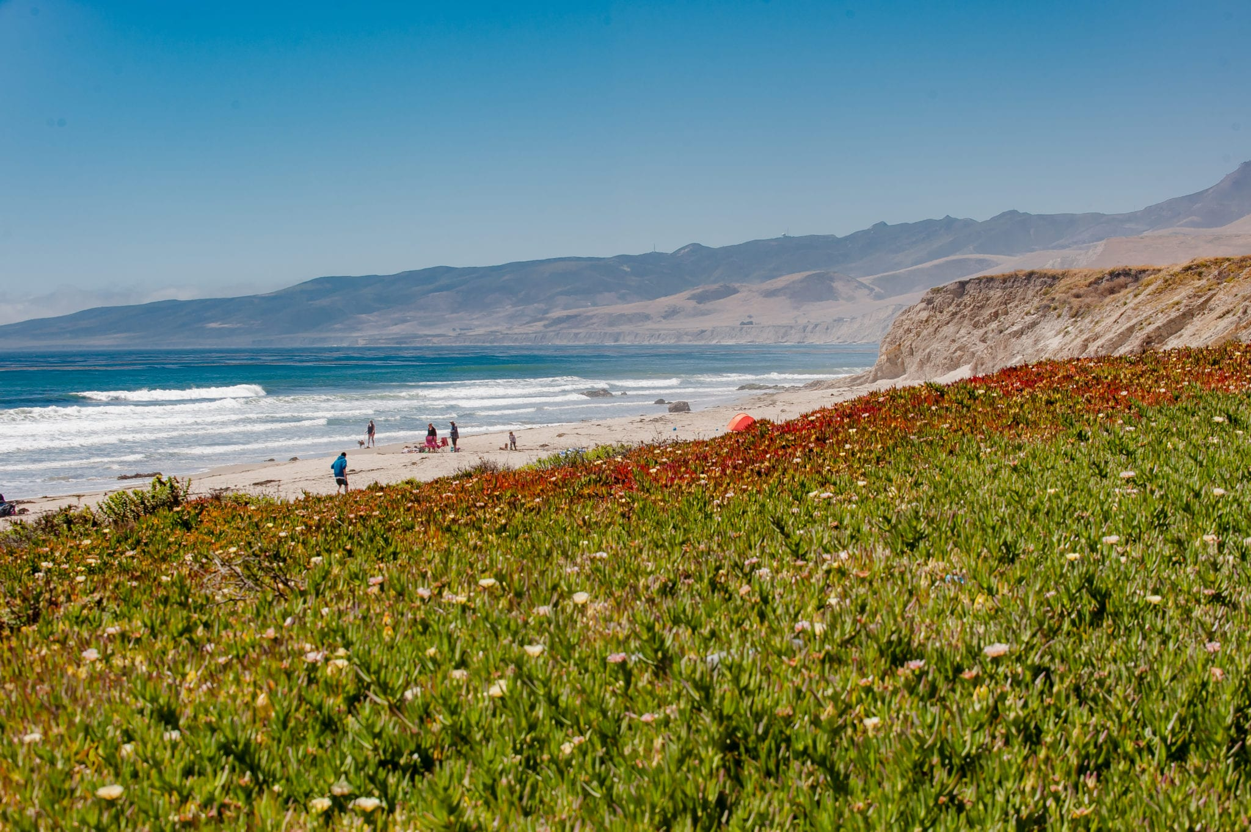
CA-SBA-205
In spring of 1990, the remains of one individual were removed from site CA-SBA-205 at Jalama Beach. Located north of Point Conception, this was the location of the Purisimeno Chumash village of Shilimaqshtush during the Historic period. The first historic accounts of Shilimaqshtush suggest that the village was populated by about 140-250 people who occupied upwards of 30 houses. Occupation of CA-SBA-205 has been dated to the mid-1400s without evidence for earlier occupations. The remains are a small human bone fragment as well as a deciduous tooth. Initial analysis claimed that the tooth was lost naturally during the life of a child, and did not represent the remains of a burial. No AFOs were identified by researchers at the site, though some may exist in associated collections. ERC Environmental and Energy Services Company, Inc. (ERCE) was responsible for excavation, with Timothy Hazeltine serving as principal investigator. The collection was received by the RAEC as Accession 489.

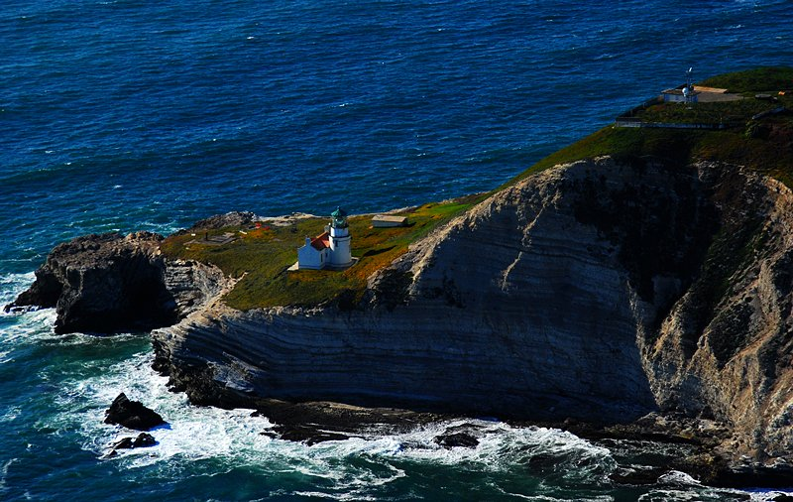
CA-SBA-541
In 1995, the remains of one individual were salvaged from a looter’s pit at Humqaq, Point Conception, also known as Bixby Ranch and now the Jack and Laura Dangermond Preserve, which is owned by the Nature Conservancy. The remains were removed by Phil Walker and John Erlandson, and received by the RAEC as Accession 734. Various associated funerary objects are included in the collection, including lithics, shell beads and abalone shells. Unfortunately, there is no known period of origin.

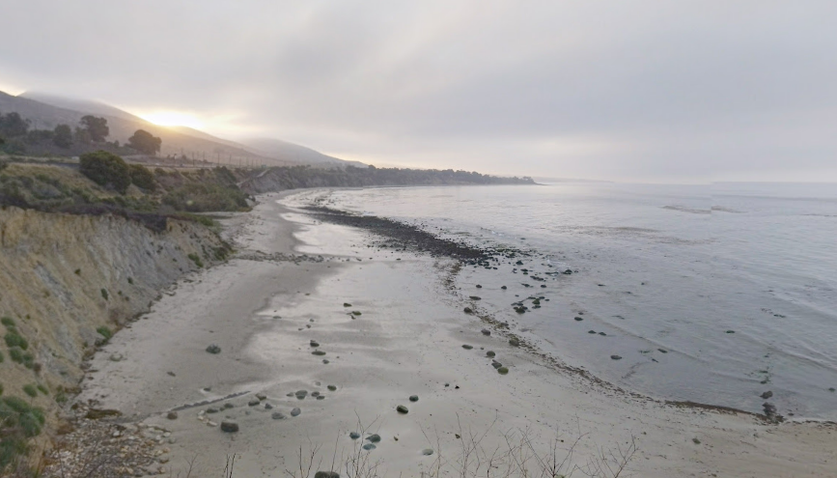
CA-SBA-1731
In winter 1988, the remains of one individual were removed from CA-SBA-1731. The site is located approximately 18 miles west of Santa Barbara, California, on a low terrace adjacent to the beach about 65 meters east of the mouth of Corral Creek. The remains contain a single human deciduous molar. Excavations were conducted to mitigate direct impacts to SBA-1731 resulting from the construction of an oil and gas pipeline by Exxon Company, USA and resulted in an extensive report. Dames and Moore was responsible for excavation, with Joyce Gerber serving as principal investigator under the Santa Ynez Unit Development Project. Based on an analysis of the seacliff profile and materials excavated, the report concluded that: the eastern portion of the site was the major residential area while the excavated western portion, lower and subject to inundation, was used mainly as a peripheral activity area in which stone tools were manufactured and retooled, animals were butchered, and fish cleaned. Radiocarbon samples recovered from the seacliff reveal both a prehistoric and historic occupation of the site. Dating of the prehistoric occupation indicates the major occupation to have taken place between A.D. 850 and A.D. 1150. The collection was received by RAEC as Accession 428.

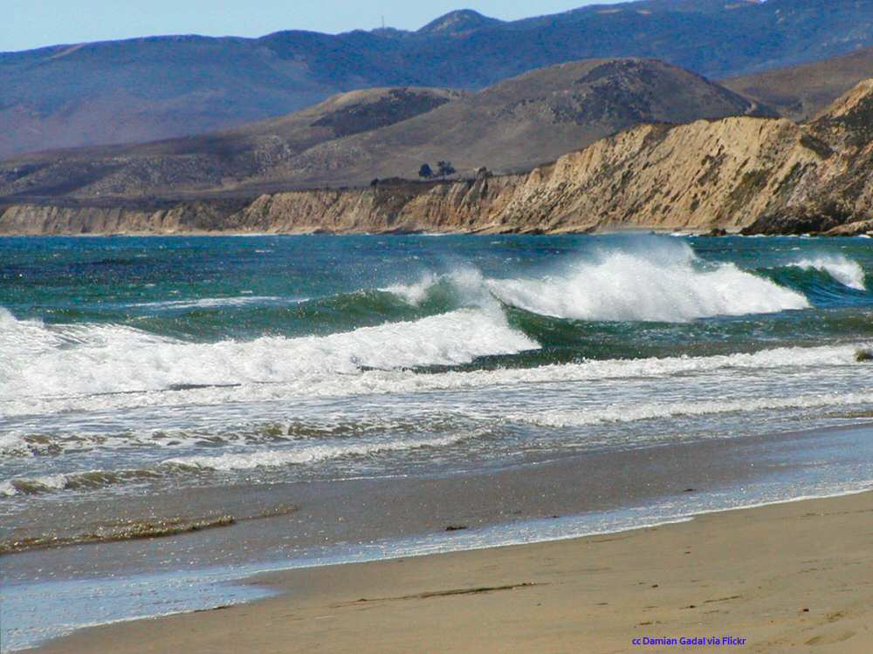
CA-SBA-2014
Inventoried in 1991, the remains of three adult individuals most likely from a burial site known as “The Gate Site,” corresponding to CA-SBA-2014 (also known as Gate Site #3), as designated by the Central Coast Information Center (CCIC). The remains are composed of the following: one right distal humerus, one right femur shaft fragment (sub-trochanteric region), one left tibia shaft fragment, one left distal fibula, one right femur shaft fragment (sub-trochanteric region), one left rib fragment, one left proximal ulna, one metatarsal, one ulna shaft fragment, one left talus, one innominate fragment, one fibula shaft fragment, one left radius shaft fragment, one
fibula shaft fragment, one left proximal femur, one rib fragment, one left femur shaft, one
right proximal femur, one left distal tibia, one right distal humerus, one innominate
fragment, and skull fragments. The human remains were inventoried by Pat Lambert in fall 1991. The collection was received by RAEC as Accession 523.

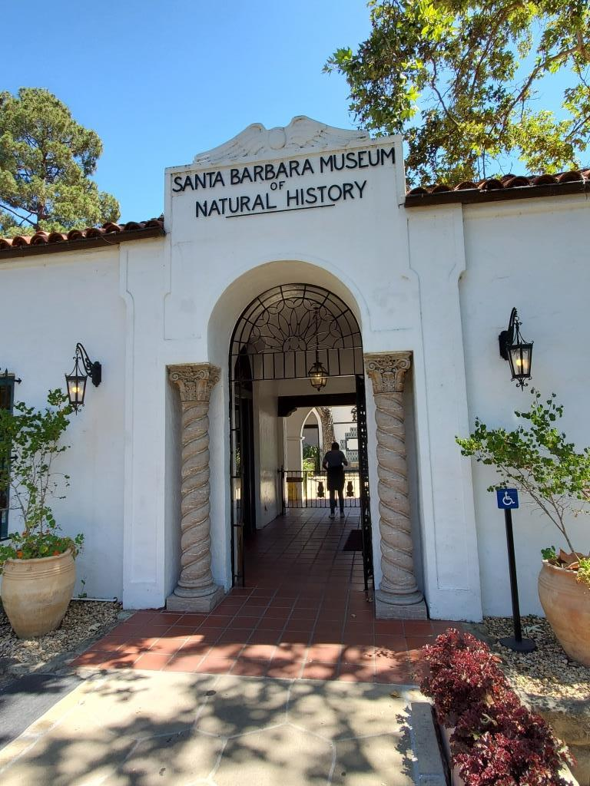
SK99
The remains of one individual were removed from a location identified only as “Cañada de Molino,” “halfway between Refugio and Gaviota State Beaches.” SK99 refers to an outdated numerical system used by an archaeologist at the Santa Barbara Museum of Natural History (SBMNH) who excavated in the Chumash region. Records suggest that the excavation was spurred by “evidence of looting.” The remains, which contain one skull and mandible of an adult male, arrived at UCSB as part of the Peter and Virginia Bancroft Indian Artifacts Collection, donated in 1995 and received by the RAEC as Accession 573.

Deer Creek near Malibu, Los Angeles County
At an unknown date Charles Rozaire (1927-2016), former Curator of Archaeology at the Los Angeles County Museum of Natural History collected the remains of a male individual from Deer Creek near Malibu. The remains themselves are composed of a skull and mandible. There is, unfortunately, no documentation of how these remains came to be held at the RAEC, but they are believed to be a part of a donation. They are a part of Accession 520.

Accession 522
Accession 522 is composed of at least four individuals which came to UCSB’s Repository through the Allan Hancock College of Lompoc. The remains are of three adults, and a 16–20-year-old female. Unfortunately, nothing else is known about them. Dental features and the condition of all remains are evidence that they are Native American. There is no information regarding whether they are from a local site, or even from the same site.

Year | Acc. | Site | Burial | Location | Lat | Long
Winter 1988 | 428 | CA-SBA-1731 | 1 individual | West of Santa Barbara, on a terrace east of Corral Creek | 34.462 | -120.043
Spring 1990 | 489 | CA-SBA-205 | 1 individual | Jalama Beach | 34.5093 | -120.499
Unknown | 520 | Unknown, likely donation | 1 individual | Deer Creek | 34.07644 | -118.991
Unknown | 522 | Donation | 4 individuals | Allan Hancock College | n/a | n/a
Inventoried 1991 | 523 | CA-SBA-2014 | 3 individuals | The Gate Site, Jalama | 34.5093 | -120.499
Donated 1995 | 573 | SK99 | 1 individual | Canaliño, near Carpinteria | n/a | n/a
Spring 1996 | 614 | CA-SBA-93 | 1 individual | Cañada del Molino, near Gaviota | 34.4687 | -120.169
1995 | 734 | CA-SBA-541 | 1 individual | Point Conception | 34.4499 | -120.444
Table 1: Summary of the collections available for the initiation of consultation

